**PROJECT TITLE :** Traffic rules and regulations in Bangladesh

**Objective:**

The main objective to use this software to reduce traffic jams in all city of Bangladesh. Now adays traffic jam is a major problem. Due to traffic, people can’t move properly. Many of us can’t attend the classes, offices at due time. Also , people died in ambulance for jam. Also for over speed accident occurs lot and peple died for it. And for wrong parking jam occurs too . Moreover, the road become narrow. And, It is too much pathetic . Life become miserable for all , and can’t move freely.

So, For this problem, we decide to use a Application which is called **Traffic rules and regulations in Bangladesh .** to reduce the jam and people can move freely. If we discuss about the project and the application , there many way to reduce the current problem . First of all , if anyone cross the speed limit by car or bike and other vehicle ,he or she have to take tickets which is damage the person .and by taking this step many people try to maintain their vehicle speed .

anothe if we talk about traffic police , we also reduce the traffic police in bangladesh . because by this application we may introduce some of camers and somer software ,which is very common in abroad . this feature capture person and persons vehicle , which goes around over speed or wrong parking or carry over weight and also if any one use mobile phone when hw or she drive the car this feature capture it and without any traffic police, the victim have to carry a ticket so it should be clearly damage the person and slowly the total problems reduce . also by another feature all road car maintain the traffic rules without traffic police .

**Key Features:**

1. Over speed .
2. Signal break .
3. Wrong parking .
4. Wrong way road .
5. Over loaded truck or carrying over weight vehichle.
6. Suddenly Bus stop for long time .
7. Call ditective . ( Using mobile phone when he or she was drive)
8. Traffic congestion .ETC

**Benefits:**

1. Traffic jam reduces .
2. Driver’s won’t break the signal easily .
3. Road will be good and the road will not be damaged by overloaded car or trucks .
4. Reduces the accident in Bangladesh .
5. Proper rules for all types of people . in this application everyone equal for this problmes .
6. All roads are not easily damage so it is also benefit side .

**Solutions:**

To solve the problem at first the traffic should be reduces. Using this Application , drivers can’t neglect the rules and regulation, if deny then drivers have to give penalty for that. Moreover by this Application allow the signal after 5 minutes so that there is no jam. Also this Application have some function for which the truck won’t be overloaded and the road will not be destroyed. I think there is no previous solution of this application in Bangladesh . so we try to make it clear and try to traffic free country .

**Functional Requirement :**

**1: Software fundamental** : There are some software which are uses for identified the issue and this software are mini camera , Measurement sensor, normal sensor . Mini camera capture the vehicles information and hidden camera ,and , sensor measurement other things.

**2: Information Collector :** Information Collector User will be able to generate to Collect the users information And pass the information and any issues to the Control panel .

**3: Control panel :** Control panel should be collect the users information from information collector and then check the rules break list and then make a list of fine for the rules breaking users also alert the users by SMS . Also monitoring the expired date for pay the fine .

**4: User verification :** Every user should be verified by providing Phone number , NID , driving licenses copy , Vehicles number plate .

**5 : User details :** User will be able to see their fine information and the expired deadline of submitting the fine .

**6 : Payment System** : If users break the rules at that time control panel send a fine information and on that information there are a code of the fine list .then the user pay the fine by online payment system and uses the code for identify his account .

**7: Over speed :** If users cross the speed limit , the sensor software notify if by itself and pass the information to the information collector

**8: Signal break** : If the users break the system or break any signal line during traffic , then the camera capture the vehicles number plate and also capture the breaking system .

**9: Call detective :** Hidden camera basically notify the information who uses the mobile phone during driving . so the camera capture the photo and pass it to the control panel . and control panel user should be identify the person and make a fine list for the user.

**10: Wrong parking** : If users park the vehicles in wrong road for more then 10 minutes at that time the sensor will be notify the control panel and the user of control panel should be step or make a fine for the owner of the vehicle.

**11: Wrong way :** If the usersbreak the rules and then go through the wrong road at that time the hidden camera capture the number plate of the vehicles .

**12: Motorcycle safety issues :** If any users use motorcycle and they don’t follow instruction like wearing helmet and not allow two person in one motorcycle . at that time the mini camera captures the motorcycle number plate and pass the information to the information collector.

**13: Over loaded truck or carrying over weight vehicles:** In one way road there are a sensor in the middle of the road and every vehicle must be cross the road over the sensor and if any truck carry over loaded the sensor notify it and the hidden camera pass the number plate picture on the control panel .

**14 : License issue :** If the users break rules for more then 5 times in one month at that time the license of the user must be wipe out for 6 month .

**15: Warrant issue :** If any person break any rules and the person not payment the fine at that time the control panel must be make a warrant issue for the vehicle.

**14: User Review** : User will be able to review the whole application and also rating the application part.

**Use Case Diagram**

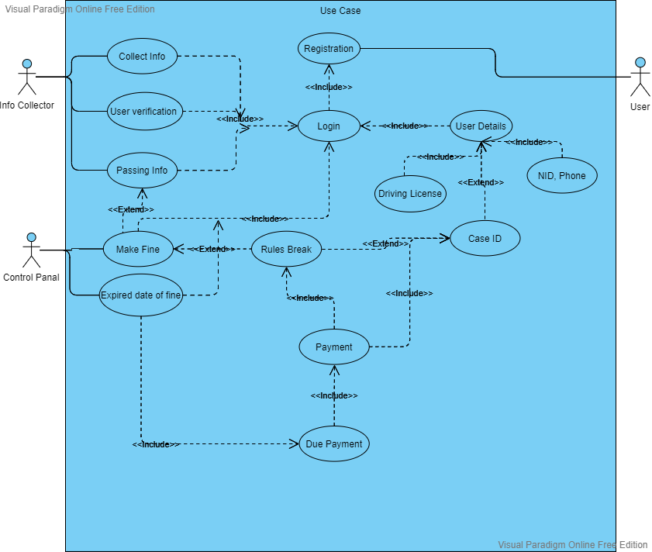

**Class Diagram:**

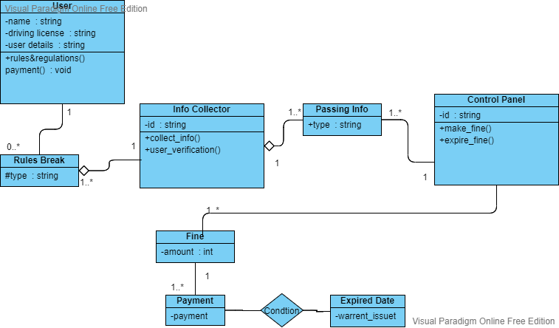

**Activity Diagram**

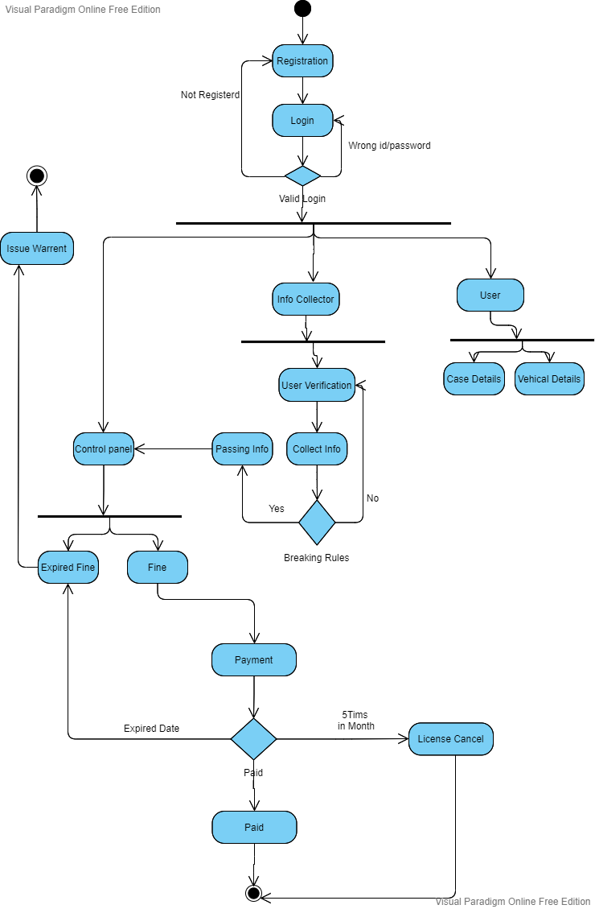Sequence Diagram

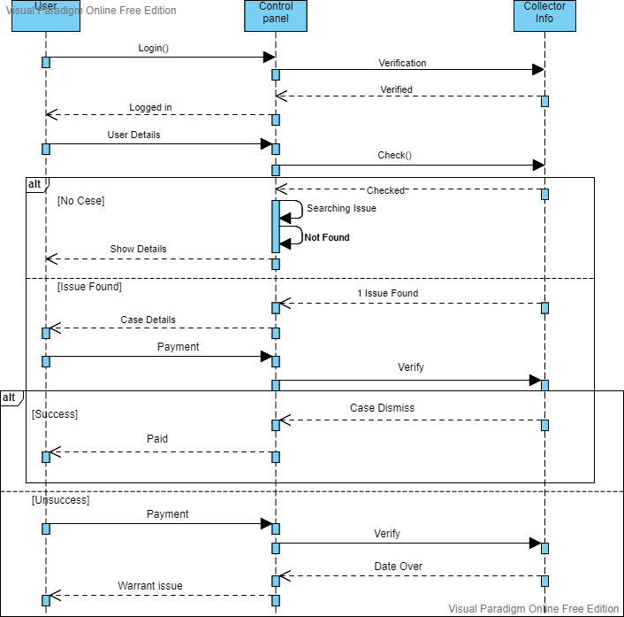

**Description of the used Software Process Model**

The incremental model goes with our project. Our project is Smart traffic system. As the project is small but the settings and requirements are high just like in our projects consists of camera, identify ,overload System are included .

Moreover the process is lengthy ,it needs to checks all the stages again and again. So, if there is an error then it could be fix at the time of developing . Also , change can be make at later on by adding or removing. That’s why incremental model goes with our projects.

Normally to other model there is no scope for funding schedule, risk, programme complexity ,but in case of incremental there is possibility for this benefits.

Again, the requirements are clearly understood for incremental just like as the project has lengthy development schedules, a new technology, can also early release when products arises, it have high -risk features . This method is more used for web applications .

At the time of need to have basic functionality delivered as soon as possible . requirement are needed for the project are prioritized . Finally, most of the requirement needed are known before to the starting of the project , but they are expected to change as the project progresses .

As the settings and requirements are high , so, the scrum role and method goes with it . Because it makes the agreement when the requirement are completed and can make final decisions of the tasks .

If there is an error then it can fix it. Moreover there is no function to change the system every few months , which is highly recommend for this project.

In case of other role and method there are constantly changing requirements or work with customers Who arenot sure what they want the system to do. But , in case of scrum there is high chance to work with the customers.

A small number programmer prefarable for others, in case of scrum a large number programmer prefarable which suits with our project. For others it able to create automated and functional tests but for scrum its not recommended and for our projects too.

So, from this view we can said that, the incremental model and scrum role and method are suitable for our projects